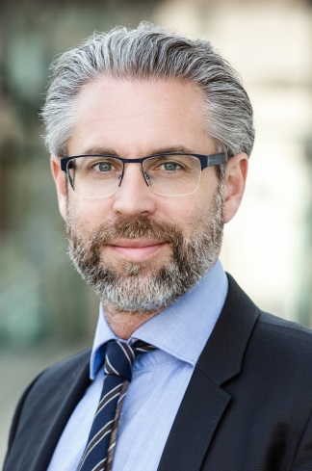
Assoc. Prof. PD Christian Enzinger, MD, MBA, FEAN
Christian Enzinger, MD, Assoc. Professor;
Officiating Head Dept. of General Neurology
Director of Research Unit for Neuronal Plasticity & Repair
University Clinic of Neurology
Auenbruggerplatz 22, A-8036 Graz
Medical University of Graz, Austria
Tel. 0043 316 385 82180
Fax. 0043 316 385 16808
http://neurologie.uniklinikumgraz.at/
e-mail: chris.enzinger@medunigraz.at
ORCiD: 0000-0001-9764-7617

Christian Enzinger obtained his medical degree at the Karl-Franzens-University of Graz (Austria) in 1998 and he became a Board Certified Neurologist in 2006. He received specific training in neuroimaging as a Research Fellow at the Centre for Functional MRI of the Brain (FMRIB) at the University of Oxford.
He is Full Professor of Neurology, Head of the Department of General Neurology including a Stroke-Unit at the University Clinic of Graz, and Head of the MS outpatient unit at the Department of Neurology.
He has been co-chair of the MAGNIMS group (Magnetic Resonance in Multiple Sclerosis) and co-Chair of the Panel Neuroimaging of the European Academy of Neurology, and he is a board member of the Austrian Stroke Society and president-elect of the Austrian Society of Neurology. He is also organizing the national MS academy and has contributed to teaching in the field of MS and cerebrovascular disorders at various international conferences.
Enzinger is actively involved in research on MS and cerebrovascular disorders, at both the national and international level, resulting in more than 300 papers in peer-reviewed journals. His specific research focus lies on the use of MRI in elucidating the heterogeneity of and studying mechanisms of repair and functional plasticity in MS, ageing, and cerebrovascular disease. Dr. Enzinger and his team have received several prizes in recognition of their scientific work.

